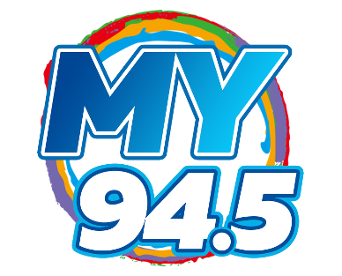
My 94-5 Lyric Sheet

THEME A
Original: More music variety… My 94 5
New: (Your lyrics here)

THEME B
Original: More music variety… My 94 5
New: (Your lyrics here)

THEME C
Original: More music variety… My 94 5
New: (Your lyrics here)

THEME D
Original: More music variety… My 94 5
New: (Your lyrics here)

THEME E
Original: More music variety… My 94 5
New: (Your lyrics here)

THEME F
Original: More music variety… My 94 5
New: (Your lyrics here)

THEME G
Original: More music variety… My 94 5
New: (Your lyrics here)

THEME H
Original: More music variety… My 94 5
New: (Your lyrics here)

TOP OF HOUR
Original: More Music Variety… My 94 5… Madison
New: (Your lyrics here)

WEATHER
Front: Madison Weather
New: (Your lyrics here)
Tag: More Music Variety… My 94 5
New Tag: (Your lyrics here)

